NIRA SOLUTIONS-
UI/UX DESIGN-
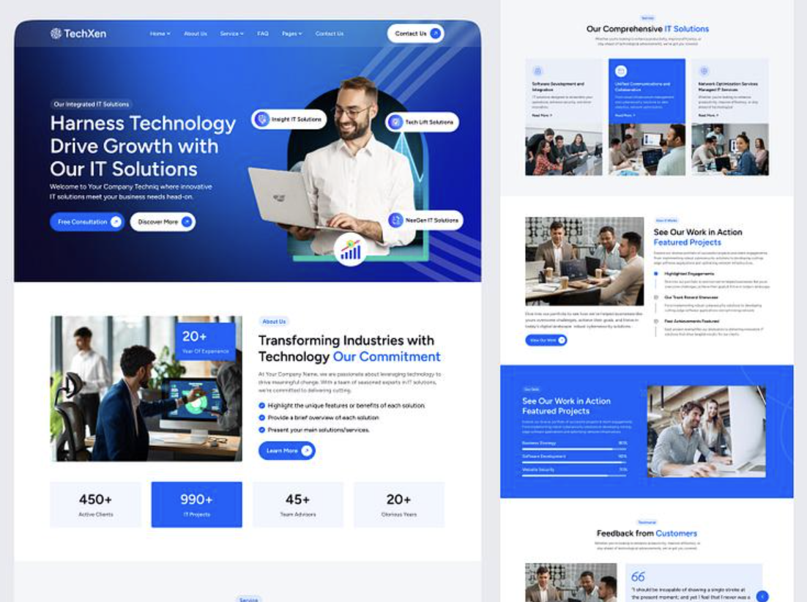

LOGO Home About Us Services ▾ Industries Global Presence Contact

HOME PAGE

PEOPLE. PROCESS. TECHNOLOGY.

Building Capability.

Transforming Business.

Delivering Value.
NIRA SOLUTIONS is one of the leading Integrated Manpower, Consulting & Technology Solutions company in the middle east with its global presence in UAE, INDIA, U.K and AUSTRALIA. We combine regional expertise, specialist capabilities and global delivery resources to solve complex business challenges.
10+ YEARS
UAE Market Experience
4 GLOBAL LOCATIONS
Dubai • London • Delhi • Australia
3 CORE CAPABILITIES
Manpower • Consulting • Technology
ONSHORE + OFFSHORE
Flexible Global Delivery Model

WHO WE ARE

One Partner for People, Process & Technology.
Modern businesses face three interconnected challenges: finding the right people, building the right processes, and implementing the right technology.
We bring all three together.
Our integrated business model combines specialised manpower solutions, management and procurement consulting, and technology services under one platform.
This allows our clients to engage one strategic partner capable of supporting both immediate operational requirements and long-term transformation.

OUR CORE SERVICES

Three Capabilities. One Integrated Solution.
Our capabilities are designed to work independently or together, allowing clients to select the services that best meet their requirements.

01 | MANPOWER SOLUTIONS

Talent Without Boundaries.
Finding the right skills at the right time can determine the success of a project or transformation programme.
We provide flexible and scalable manpower solutions that give organisations access to specialised professionals without the complexity and long-term overhead associated with traditional workforce models.
Our resources can work onshore, offshore or through a hybrid delivery model, depending on the client's operational and commercial requirements.

Our Manpower Capabilities
Staff Augmentation
Extend your existing workforce with qualified professionals for short-term, long-term and project-specific requirements.
Consulting Resources
Deploy experienced specialists and subject-matter experts for strategic projects and transformation programmes.
Payroll Management
Simplify payroll and workforce administration for outsourced and contract employees.
Onshore Resources
Locally deployed professionals who work directly alongside client teams.
Offshore Resources
Dedicated offshore resources providing scalable and cost-efficient support.
Project-Based Teams
Build dedicated teams around defined projects, programmes or business requirements.

Flexible Workforce. Greater Scalability.
Our model enables businesses to scale resources according to demand while maintaining greater control over workforce costs.

02 | CONSULTING

Turning Business Challenges Into Measurable Value.
Our consulting practice specialises in procurement transformation, strategic sourcing, cost optimisation, managed procurement services and digital procurement.
We work with organisations to identify opportunities, challenge existing ways of working and implement practical solutions that create sustainable commercial savings.
Our consultants combine strategic thinking with hands-on implementation experience. We don't simply recommend change—we help organisations deliver it.

PROCUREMENT TRANSFORMATION

Build a Procurement Function Designed for the Future.
We help organisations assess, redesign and transform procurement functions across strategy, organisation, processes, governance, technology and performance management.
Our capabilities include:
Procurement Strategy • Target Operating Model • Policies & SOPs • Governance • Category Management • Supplier Management • Performance Management • Digital Procurement

STRATEGIC SOURCING

Better Sourcing. Better Commercial Outcomes.
We support the complete sourcing lifecycle from spend analysis and market assessment through tendering, negotiation, contracting and implementation.
Our structured sourcing methodology helps organisations improve commercial outcomes while balancing cost, quality, service, innovation and risk.

COST OPTIMISATION

Every Spend Category Has an Opportunity.
We conduct structured cost optimisation exercises to identify immediate and sustainable savings opportunities across organisational expenditure.
Our methodology:
SPEND ANALYSIS
↓
OPPORTUNITY IDENTIFICATION
↓
DEMAND OPTIMISATION
↓
STRATEGIC SOURCING
↓
COMMERCIAL NEGOTIATION
↓
IMPLEMENTATION
↓
SAVINGS TRACKING
Our focus extends beyond price reduction to improving Total Cost of Ownership and long-term commercial value.

MANAGED PROCUREMENT SERVICES

Extend Your Procurement Capability.
Organisations can outsource specific procurement activities, categories or sourcing programmes to our specialist procurement teams.
We can support:
Strategic Sourcing • Tender Management • Category Management • Supplier Negotiations • Procurement Analytics • Contract Support • Supplier Performance
This enables organisations to quickly increase procurement capability without permanently increasing internal headcount.

DIGITAL PROCUREMENT & E-SOURCING

Procurement Powered by Technology.
We help businesses digitise sourcing and procurement through technology-enabled workflows and integrated procurement platforms.
Our capabilities include:
E-Sourcing • Digital Tendering • Supplier Portals • Procurement Workflows • Approval Automation • Procurement Analytics • ERP Integration
Our combination of procurement and technology expertise allows us to design solutions around real procurement requirements rather than technology alone.

03 | IT & DIGITAL SERVICES

Technology Built Around Your Business.
Technology should enable business—not complicate it.
We design, develop and integrate digital solutions that automate processes, connect information and provide organisations with greater operational visibility.
Our technology capabilities range from individual applications and websites to customised enterprise platforms and ERP solutions.

CUSTOM SOFTWARE DEVELOPMENT
We develop secure, scalable software solutions designed around specific business requirements and workflows.
Our development lifecycle covers:
Discovery → Architecture → UX/UI → Development → Testing → Deployment → Support

ERP DEVELOPMENT & INTEGRATION
We develop and customise enterprise solutions that connect critical business functions and create a single source of operational information.
Our ERP capabilities can support:
Procurement & Sourcing
Finance & Accounting
HR & Payroll
Supply Chain
Inventory Management
Vendor Management
Contract Management
Project Management
Reporting & Analytics

SYSTEMS INTEGRATION
Connect applications, databases and third-party platforms to create seamless information flows across your organisation.
We help eliminate disconnected systems, duplicate data and unnecessary manual processes.

MOBILE APPLICATION DEVELOPMENT
We design and develop intuitive mobile applications for iOS, Android and cross-platform environments.
Solutions can support customers, employees, suppliers and business partners.

WEBSITE & WEB APPLICATION DEVELOPMENT
From corporate websites to sophisticated business applications, we build responsive, scalable and user-focused digital platforms.
Our capabilities include:
Corporate Websites • Customer Portals • Supplier Portals • E-Commerce • Web Applications • Business Platforms

MANAGED IT SERVICES
We provide ongoing application support, maintenance, system enhancements and technical services to help organisations maintain reliable and efficient technology environments.

OUR DELIVERY MODEL

Local Expertise. Global Delivery.
Our international footprint allows us to combine local client engagement with global talent and cost-efficient delivery capabilities.

DUBAI
Middle East Headquarters
Client engagement, consulting, programme management and regional delivery.

LONDON
UK & European Operations
Business development, consulting and European market support.

DELHI
Technology & Offshore Delivery
Software development, technology services, specialist resources and offshore delivery.

AUSTRALIA
Asia-Pacific Operations
Regional consulting, technology and business support.

One Team. Multiple Delivery Models.
Depending on the client's requirements, our services can be delivered through:
ONSHORE
Client-facing resources deployed locally.
OFFSHORE
Dedicated resources operating through our global delivery network.
HYBRID
A combination of local leadership and offshore delivery.
MANAGED SERVICE
We take responsibility for delivering an agreed function, service or outcome.
This flexibility enables clients to balance capability, cost, scalability and operational control.

WHY CHOOSE US

Built Around Business Outcomes.

10+ Years of UAE Experience
More than a decade of regional experience gives us a strong understanding of the UAE business environment while our international footprint provides access to global capabilities.

Integrated Expertise
Instead of engaging separate manpower, consulting and technology companies, clients can access all three capabilities through one strategic partner.

Flexible Engagement Models
Our solutions can be structured around your business requirements through:
Staff Augmentation | Dedicated Resources | Consulting Projects | Managed Services | Offshore Teams | Technology Development

Commercially Focused
Our approach is built around measurable business outcomes—whether that means reducing cost, increasing productivity, accelerating delivery or improving operational performance.

